Step One: Connecting router and laptop cables

I. Connect cable to the Uninterruptible Power Supply (UPS)
Uninterruptible Power Supply (UPS)  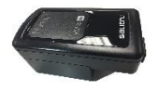 | UPS Charging Cable- A  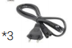

II. Connect the network cable between the laptop and the router.
Router  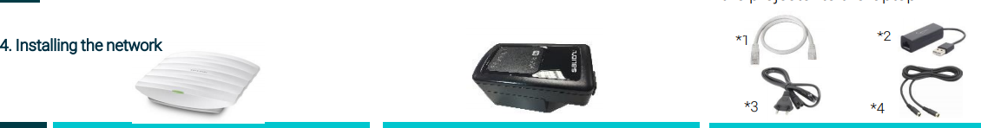 | Network Cable- B | Adaptor- C 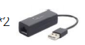 | Laptop  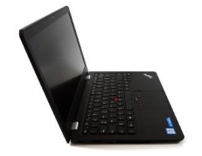

III. Connect Router to Uninterruptible Power Supply UPS
Router | Connect Router to UPS- D  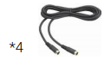 | Uninterruptible Power Supply (UPS) | Wait a few seconds and check that the Router light has come on.  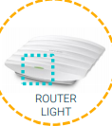

IV. Finally, turn on the laptop by pressing the On/Off button.
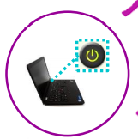
Step Two: Accessing the ProFuturo platform

